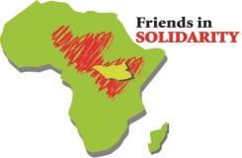

**Prayer for South Sudan**

**Commemorating Independence Day**

**July 9**

**Call to Prayer**

Leader: Make us instruments of your peace.

All: Allow instruments of peace to rise up in South Sudan and flourish all over your world:

Leader: Instruments of peace who offer stability, safety, and justice that bring joy and hope;

All: That foster hearts of reconciliation, mercy, and love.

**Reading**

**Reader 1:** In a land where traditionally you’d look for a steeple and a cross to identify a church, today in South Sudan you’re just as likely to find a church by looking for a collection of dirty, tarp-covered rustic huts, where the internally displaced have sought refuge from the country’s seemingly incessant fighting. Father Marko Mangu lives on the grounds of the Cathedral of St. Mary, where almost 10,000 internally displaced people - no one knows an exact number - continue to find refuge. That number is down from the height of the violence in 2017, when more than 16,000 people sought safety inside the compound’s crumbling walls, but priestly privacy is still just a memory. In the words of Fr. Mangu, “It’s a challenge to live here. The problems are endless. You either have to be a priest or someone extremely committed to the people, or you will get tired and quit.” *(Pause)*

**Reader 2:** Since civil war began to rip apart South Sudan’s fragile democracy in 2013, roughly one-third of the country’s 12 million people have been forced to flee their homes. In Wau the national conflict took on starkly ethnic overtones when soldiers of the Sudan People’s Liberation Army, mostly members of the dominant Dinka tribe, attacked a mixture of local opposition groups and members of other ethnic communities in 2016. More than 400 people were killed and some 120,000 had to seek refuge in churches and a nearby United Nations base, as soldiers looted and burned many local communities. *(Pause)*

**Reader 3**: Angelina Polu, a member of the Balanda tribe, says her son was killed by the Sudan People’s Liberation Army soldiers. She lives on the cathedral grounds with her grandson. “I want to go home, but there are too many guns out there. And my house is gone. The Dinkas took it.” *(Pause)*

**Reader 4:** Some 250 miles to the south, Father Victor Babie also lives surrounded by the internally displaced. As the priest in Riimenze, a once-sleepy village near the border with Congo, he’s also the de facto mayor of 7,030 displaced people - he knows the exact number - who continue to seek safety in the shadow of the church. With help from groups like Solidarity with South Sudan, the Catholic Medical Mission Board and the Congregation of Bon Secours, he provides water, food, medical care, education and hope to the community. (*Pause)* *(Catholic News Service, April, 2018)*

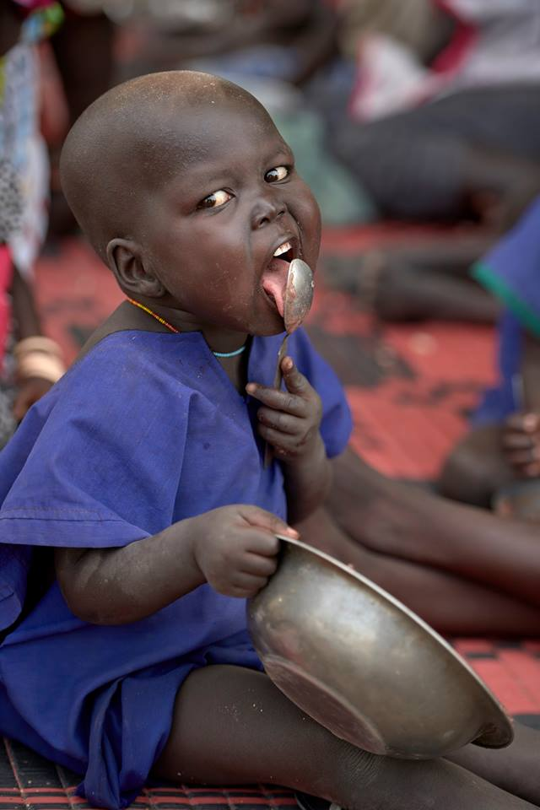

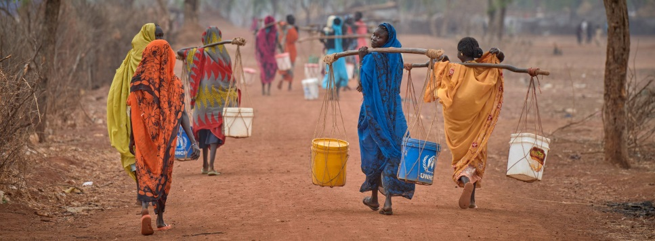

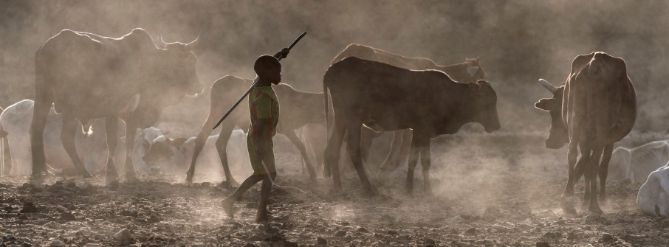

**Our heavenly Father always listens to his children who cry to him in sorrow and anguish, who ‘heals the brokenhearted and binds up their wounds.’** (Psalm 147:3)

**I make a heartfelt appeal so that we also listen to this cry and, each one of us in his/her own conscience before God, ask ourselves, ‘What can I do for peace?’”**

**Pope Francis**

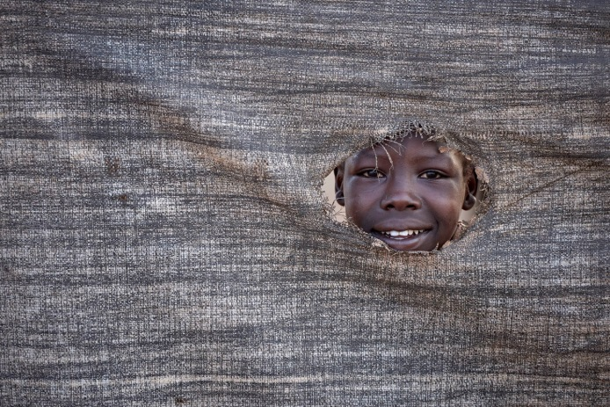

**Reflection:**

In these troubled times, and especially in these times in South Sudan, what can you do for peace?

**Intercessions:**

* We pray for the government leaders and armed groups who are at war. May they be converted by the Spirit of God to uphold the interests of the people. May leaders initiate dialogue to end all war. We pray to the Lord…
* We pray for the conversion of our hearts. The hearts of those leading the world at the international level; may God touch their hearts and fill them with love. We pray to the Lord…

We pray for the conversion of our hearts. The hearts of those leading the world at the international level; may God touch their hearts and fill them with love. We pray to the Lord…

Photo Credits: Paul Jeffrey

* We pray for all the people who represent the crucified body of Christ in South Sudan and the Democratic Republic of Congo, so that built on strong faith, they may show courage and perseverance and believe that victory over violence is possible. We pray to the Lord…
* We pray for the Church in these countries. May the initiatives of the peace and development by Apostolic Nuncios, Episcopal Conferences, Solidarity with South Sudan, the Laity, the Religious and Priests bear fruit in bringing peace and reconciliation in these countries. We pray to the Lord…

**Prayer**

God of Justice,

The prophet Jeremiah likened your

saving justice to towering mountains.

And so do we.

May your justice tower over the

people of South Sudan:

Upholding the righteous,

Protecting the widow and orphan,

Staying the hand that seeks violence,

Reconciling brother with brother,

Sister with sister,

Your children with each other.

God of Plenty,

Your Son showed us how in faith, prayer and generosity,

Your bounty could be multiplied.

And so will we.

Bless South Sudan with a bountiful harvest;

Let this conflict not dry its fields

Or close its markets

Or still its people's desire to share what they have.

Banish famine from their land

And turn the hearts of all to those who hunger

That we may all share what you have blessed us with;

That their baskets may be filled,

That their cups may overflow,

That their children may flourish.

Amen. (Catholic Relief Services)



Photo Credit: Paul Jeffrey

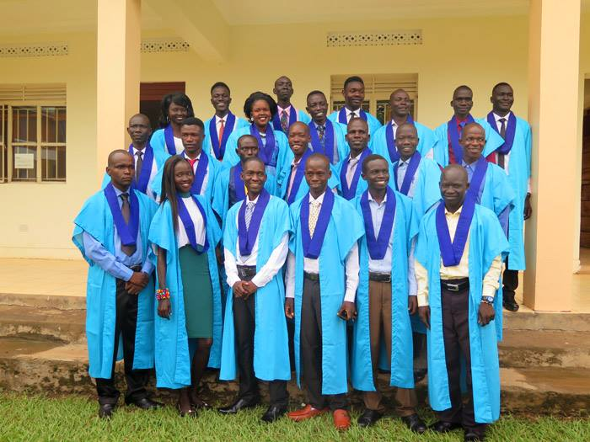

Photo Credit: Paul Jeffrey

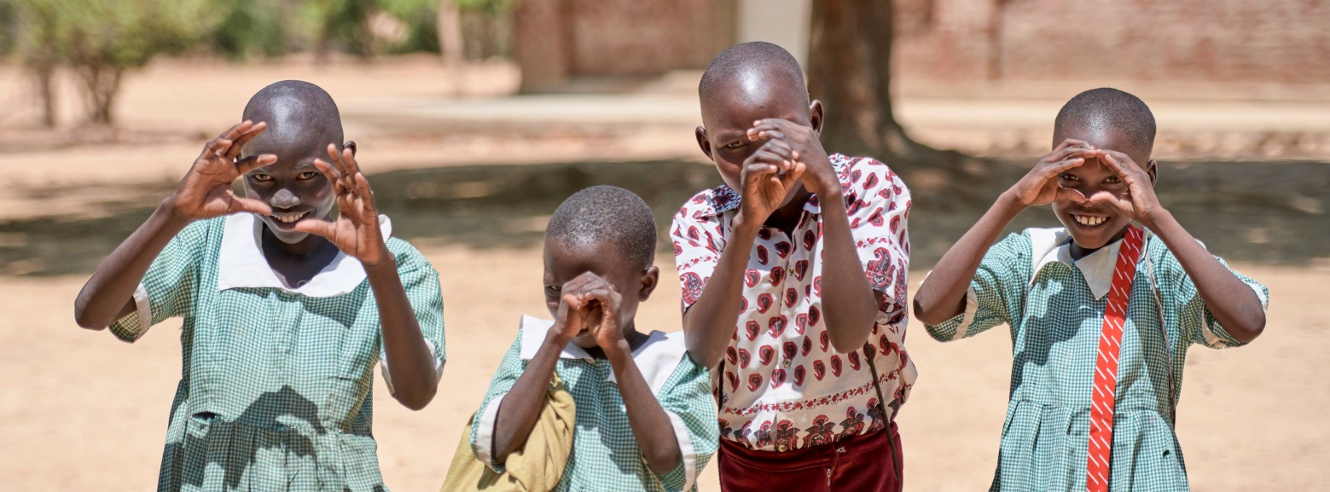

Photo Credit: Paul Jeffrey

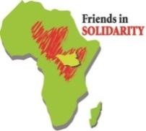

**Friends in Solidarity** *is an initiative of US Catholic Men and Women Religious in support of religious working in South Sudan and beyond. It was incorporated in November 2015 as an outgrowth of interest in the work being done by Solidarity with South Sudan, a project begun by the International Union of Superiors General and the Union of Superiors General in Rome in response to a request of the Sudan Catholic Bishops Conference in 2006.* [www.solidarityfriends.org](http://www.solidarityfriends.org)

**Quiet Reflection and Sharing**

***In our troubled times, where do you see justice and mercy unfolding, in bud?***