February 23, 2018

Worldwide Day of Prayer and Fasting for Peace
in the Democratic Republic of Congo and South Sudan
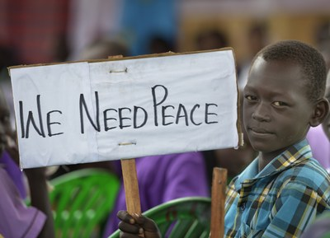
Pope Francis has invited Roman Catholics and members of all other religions to observe a day of prayer, fasting and initiatives for peace on Feb. 23, urging everyone to ‘say no’ to violence and conflict. Francis said the prayers and fasting should be offered in a particular way for the people of the Democratic Republic of Congo and South Sudan.
South Sudan has been hit by a prolonged civil war and humanitarian crisis. The Democratic Republic of Congo has been hit by unrest this month following the shooting of protesting pro-democracy churchgoers opposed to President Joseph Kabila.

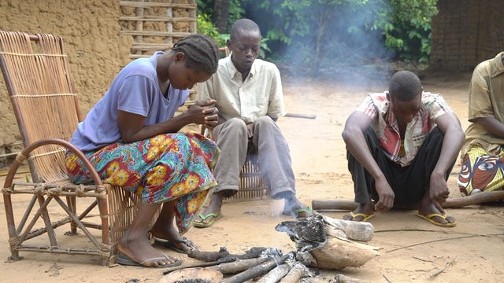
We join Pope Francis in Praying this Prayer
As Christians, we believe and know that peace is possible, because Jesus is risen. He gives us the Holy Spirit, whom we have invoked. As Saint Paul reminded us shortly ago, Jesus Christ “is our peace” (Eph 2:14). On the cross, he took upon himself all the evil of the world, including the sins that spawn and fuel wars: pride, greed, lust for power, lies… Jesus conquered all this by his resurrection. Appearing in the midst of his friends, he says: “Peace be with you (Jn 20:19.21.26). He repeats those same words to us this day: “Peace be with you!”
Without you, Lord, our prayer would be in vain, and our hope for peace an illusion. But you are alive. You are at work for us and with us. You are our peace!
May the risen Lord break down the walls of hostility that today divide brothers and sisters, especially in South Sudan and the Democratic Republic of Congo.
May he comfort those women who are the victims of violence in war zones and throughout the world.
May he protect children who suffer from conflicts in which they have no part, but which rob them of their childhood and at times of life itself. How hypocritical it is to deny the mass murder of women and children! Here war shows its most horrid face.
May the Lord help all the little ones and the poor of our world to continue to believe and trust that the kingdom of God is at hand, in our midst, and is “justice, peace and joy in the Holy Spirit” (Rom 14:17). May he sustain all those who day by day strive to combat evil with good, and with words and deeds of fraternity, respect, encounter and solidarity.
May the Lord strengthen in government officials and all leaders a spirit which is noble, upright, steadfast and courageous in seeking peace through dialogue and negotiations.

May the Lord enable all of us to be peacemakers wherever we find ourselves, in our families, in school, at work, in the community, in every setting. “Let us wash the feet” of one another, in imitation of our Master and Lord. To him be glory and praise, now and forever. Amen. (Pope Francis)
As Friends in Solidarity and supporters of Solidarity with South Sudan we have a connection to this war-torn country and therefore share in the suffering of the people. We hold Solidarity staff and students and all people of South Sudan and the Congo in our prayers for peace.
Democratic Republic of Congo
South Sudan

