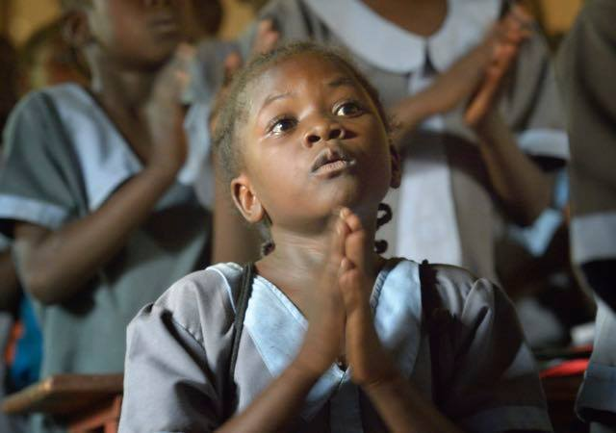**Prayer for Peace in South Sudan and the**

**Democratic Republic of the Congo**

*(Prayed in conjunction with Prayer Service in Rome lead by Pope Francis, Nov. 23, 2017, 5:30 pm)*

**CONTEXT**

**SOUTH SUDAN**, independent from Sudan since July 2011 after decades of civil war, is one of the world’s poorest countries and ranks among the lowest in many socioeconomic categories. Problems are exacerbated by ongoing tensions with Sudan over oil revenues and land borders, fighting between government forces and rebel groups, and inter-communal violence. Educational attainment is extremely poor due to the lack of schools, qualified teachers, and materials. Less than a third of the population is literate (the rate is even lower among women), and half live below the poverty line. Teachers and students are also struggling with the switch from Arabic to English as the language of instruction. Many adults missed out on schooling because of warfare and displacement.

South Sudan’s total population is estimated to be 13,000,000. Almost 2 million South Sudanese have sought refuge in neighboring countries since the current conflict began in December 2013. Another 2 million South Sudanese are internally displaced as of August 2017. Despite South Sudan’s instability and lack of infrastructure and social services, more than 240,000 people have fled from Sudan to South Sudan to escape fighting in Sudan.

Following several decades of civil war with Sudan, industry and infrastructure in landlocked South Sudan are severely underdeveloped and poverty is widespread. Subsistence agriculture provides a living for the vast majority of the population. Property rights are insecure and price signals are weak, because markets are not well organized. After independence, South Sudan's central bank issued a new currency, the South Sudanese pound. The GDP is USD 1,700 at 2016 estimates. Military expenditure is 10.93% of GDP. The economy is in collapse and annual inflation peaked at over 800% in October 2016.

**DEMOCRATIC REPUBLIC OF THE CONGO**

According to the recent estimates (July 2017 est.), the total population is 83,300,000. This takes into account the effects of excess mortality due to AIDS and decades of civil wars which results in lower life expectancy, higher infant mortality, higher death rates, lower population growth rates, and changes in the distribution of population by age and sex than would otherwise be expected. Despite a wealth of fertile soil, hydroelectric power potential, and mineral resources, the Democratic Republic of the Congo (DRC) struggles with many socio-economic problems, including high infant and maternal mortality rates, malnutrition, poor vaccination coverage, lack of access to improved water sources and sanitation. Ongoing conflict, mismanagement of resources, and a lack of investment have resulted in food insecurity; almost 30 percent of children under the age of 5 are malnourished. Maternal mortality is very high 693 deaths/100,000 live births (2015 est.)

**OPENING PRAYER**

We pray together with the Holy Father for peace in our world, and especially for peace for the people of South Sudan and the Democratic Republic of Congo who are suffering many years of silent genocide, caused by ongoing wars, hunger and displacement, political, military and ethnic violence. As disciples of Jesus, our Master, brothers and sisters, sons and daughters of the same Father, we want to be in solidarity and pray with each person suffering these conflicts. May the Holy Spirit bind us as the one family we are, and guide us in our prayer, our attitudes and our action.

We pray also for Pope Francis intentions and his coming trip to Bangladesh and Myanmar, so he can be there a prophet of peace.

**COMMENT**

Coming to this prayer implies our own commitment for peace in our daily realities. We need to acknowledge that the situations of violence in these countries are the effects of attitudes we can find rooted in ourselves; we need to pray also for ourselves so that we become real artisans of peace.

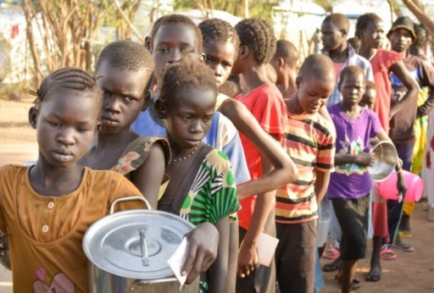**INVOCATION TO THE HOLY SPIRIT**

**( Taizé)**

**Veni Spiritu or other appropriate hymn.**

**CONTEXT**

By baptism, Christians are called to a conversion of heart and to embrace the way of our Lord. As people of faith, we are to live the pascal mystery every day. We are brothers and sisters of all who are suffering in South Sudan and the Democratic Republic of the Congo. We all need to be a comfort to one another and create the hope that together, another world is possible.

**READING**

John the Baptist called the people of his day to “Prepare the way of the Lord, make his path straight.” Jesus humbly received his message and asked to be baptized. At his baptism, a voice from heaven affirmed him with these words: “You are my Beloved Son, with whom I am well pleased.” (Mk 1, 3,11)

**COMMENT**

We are all called to be announcers of the Good News, not only in words, but by the lives we live. In whatever situation we find ourselves, we would want to hear God say to us, “You are my beloved in whom I am well pleased.” This day we are challenged to be persons of nonviolence in the midst of conflict. As Pope Francis said in his peace message, *Nonviolence: a Style of Politics for Peace*: “In the most local and ordinary of situations and in the international order, may nonviolence become the hallmark of our decisions, our relationships and our actions and indeed of political life in all its forms.”

**SILENT REFLECTION**

In what ways have I practiced active nonviolence and helped to prepare the way of the Lord?

Have I heard God say to me, “I am very pleased with you”?

**INTERCESSIONS**

Please help us to be so converted to the way of Jesus that we, authentically, announce peace because it is in our hearts. We pray to the Lord…

Help us to overcome all that divides us from others—tribalism, politics, cliques, judgments, prejudices…so that we can be in solidarity with our brothers and sisters. We pray to the Lord…

***BIND US TOGETHER***

*Bind us together, Lord*

*Bind us together   
With cords that cannot be broken.   
Bind us together, Lord,*

*Bind us together, Lord,  
Bind us together in love.*

There is only one God,   
There is only one King;   
There is only one Body,   
That is why we sing: Refrain

**CONTEXT**

Women in South Sudan and the Congo play an essential role in the survival of the family. They have been left alone in charge of the family, providing food, healing, security, education for the children and caring of the elderly. At the same time, they are being sexually abused, trafficked, and targeted - used as weapons of war. Despite all this, they are resilient and keep working, providing for the needs of their families like Mary in this Scripture passage.

**READING**

“When the wine ran short, the mother of Jesus said to him, "They have no wine."   
(And) Jesus said to her, "Woman, how does your concern affect me? My hour has not yet come."  
His mother said to the servers, "Do whatever he tells you." …When the headwaiter tasted the wine, he found it was the best. (John 2,2-5, 7-8)

**COMMENT**

Mary, like the women enduring situations of conflict, is attentive and responding to others needs, despite her own suffering and the adversities of daily life. At the same time, Mary is rooted in hope and trust in Jesus. In these countries, women are the ones who have hope for that peace that seems impossible; they are the ones available for initiatives of peace and dialogue, always thinking of the future of their beloved ones.

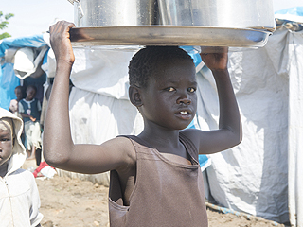

**SILENT REFLECTION**

Is Jesus the real source of our trust and hope for the future?

Are we available as servants, to do whatever the Lord indicates to build peace?

**INTERCESSIONS**

May the Lord strengthen all the women and girls in our world, who are suffering, with his Life and Hope, so they can continue to help their families to have a better life. We pray to the Lord…

We pray for all the Christians that the Lord give all of us the grace to be attentive and effective, with concrete actions in responding to the needs of others. We pray to the Lord…

**SERVANT SONG – or other suitable hymn**

**CONTEXT**

During his lifetime on earth, Jesus taught about the Reign of God. This is the task he also entrusted to his disciples and the whole Church. But evil in its different forms is fighting against the Reign of God. Unending wars are clear obstacles to the establishment of the Reign of God. Let us pray that the people of God in South Sudan and the Congo be witnesses to the Reign of God in spite of the challenges they are facing.

**READING**

For the kingdom of God is not a matter of food and drink, but of righteousness, peace, and joy in the Holy Spirit. (Letter to the Romans 14:7)

**COMMENT**

The Kingdom of God is the kingdom of love. The wars we are witnessing in South-Sudan and in the Congo are clear signs of lack of love in the hearts of those fighting, those who authorize these wars, and those who remain indifferent without assisting those suffering from war.

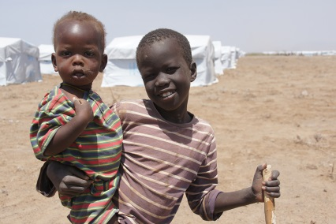

**SILENT REFLECTION**

Are we really builders of the Reign of God, or its enemy?

What can I concretely do to build the Reign of God where I am, here and now?

**INTERCESSIONS:**

We pray for the government leaders and armed groups who are at war. May they be converted by the Spirit of God to uphold the interests of the people. May leaders initiate dialogue to end all war. We pray to the Lord…

We pray for the conversion of our hearts. The hearts of those leading the world at the international level; may God touch their hearts and fill them with love. We pray to the Lord…

We pray for all the people who represent the crucified body of Christ in South Sudan and the Democratic Republic of Congo, so that built on strong faith, they may show courage and perseverance and believe that victory over violence is possible. We pray to the Lord…

We pray for the Church in these countries. May the initiatives of the peace and development by Apostolic Nuncios, Episcopal Conferences, Solidarity with South Sudan, the Laity, the Religious and Priests bear fruit in bringing peace and reconciliation in these countries. We pray to the Lord…

**MEDITATION ON THE PRAYER OF ST. FRANCIS FOR PEACE**

“Whoever accepts the Good News of Jesus is able to acknowledge the violence within and be healed by God’s mercy, becoming in turn an instrument of reconciliation. In the words of Saint Francis of Assisi: “As you announce peace with your mouth, make sure that you have greater peace in your hearts” *Pope Francis Message for Peace 1st January 2017*

**SIGN OF PEACE**

**PEACE IS FLOWING LIKE A RIVER**

Peace is flowing like a river,

Flowing out of you and me,

Flowing out into the desert,

Setting all the captives free.

2 Joy is flowing like a river, ...

3 Faith is flowing like a river, ...

4 Hope is flowing like a river, ...

5 Love is flowing like a river, ...

**BLESSING**

**May God bless you with discomfort at easy answers, half-truths, superficial relationships, so that you will live deep within your heart.**

**May God bless you with anger at injustice, oppression and exploitation of people, so that you will work for justice, equity and peace.**

**May God bless you with tears to shed for those who suffer from pain, rejection, starvation and war,**

**so that you will reach out your hand to comfort them and change their pain to joy.**

**And may God bless you with the foolishness to think that you can make a difference to the world,**

**so that you will do the things which others tell you cannot be done.**

***(Unknown. From A World of Blessing, compiled by Geoffrey Duncan)***

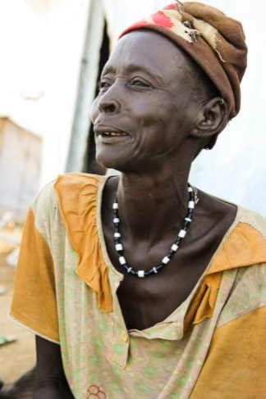**SONG OF SENDING FORTH**

**“Let there be Peace on Earth” (or other suitable hymn.)**

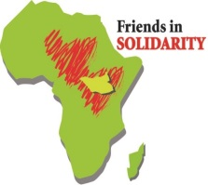

**Friends in Solidarity** *is an initiative of US Catholic religious men and women in support of religious working in South Sudan and beyond. It was incorporated in November 2015 as an outgrowth of interest in the work being done by Solidarity with South Sudan, a project begun by the International Union of Superiors General and the Union of Superiors General in Rome in response to a request of the Sudan Catholic Bishops Conference in 2006.* [www.solidarityfriends.org](http://www.solidarityfriends.org)