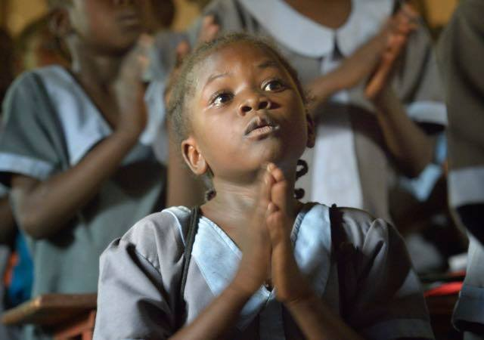

**Prayer for South Sudan**

Join us in praying with the people of South Sudan for peace.

South Sudan gained independence from Sudan on July 9, 2011 as the outcome of a 2005 peace agreement that ended Africa's longest-running civil war. Independence did not bring conflict in South Sudan to an end. Currently, more than 3.5 million people have been displaced and 7.5 million need emergency aid as a result of South Sudan’s three-year-old civil conflict. Oil revenues have declined, farming and business activities have halted in many areas, and inflation has soared. The number of people classified as “severely food insecure” is expected to reach 5.5 million by July 2017, and more than 1 million children are acutely malnourished. The world’s youngest country is now on the brink of mass starvation.

(U.N. Development Report, May 2017)

“Let us pray together that Christians in Africa, in imitation of the Merciful Jesus, may give prophetic witness to reconciliation, justice, and peace.” (Pope Francis)

“Turn from evil and do good; seek peace and pursue it.” —Psalm 34:14

Nine-year-old Kai lives in a tent with his mother and six siblings. When fighting broke out in their village, his father and grandmother died trying to flee, and the rest of his siblings — three brothers and two sisters — are still missing. “We had to flee many more times. Whenever fighting broke out, we had to run away again. I hope we are safe now,” Kai says. “I don’t want to run anymore.”

* We pray for those who have lost loved ones in the fighting and attacks.
* We pray for the 3.6 million people who have been forced to flee their homes.
* We pray that the peace agreement will be implemented and a lasting ceasefire will be reached.
* We pray for all aid workers and women and men religious who minister in South Sudan.

While her husband stayed in their home state of Unity, Adakien and her four children have moved from camp to camp over the past two years to flee the violence. She’s not sure if her husband is alive, and she has no way to contact him. “My country hasn’t made great advances in the last five years [since independence],” Adakien says. “I have seen suffering and fighting, but I am still proud. We have our own country, and I wouldn’t want to change this for anything.”

* We pray for the South Sudan churches, and the courageous work they are doing to spread powerful messages of peace.
* We pray for the 7.9 million people currently in need of urgent humanitarian assistance in South Sudan.
* We pray that the international community will provide the immediate assistance and longer-term support needed by the people of South Sudan.

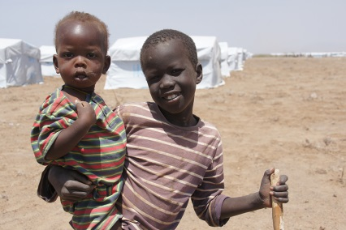

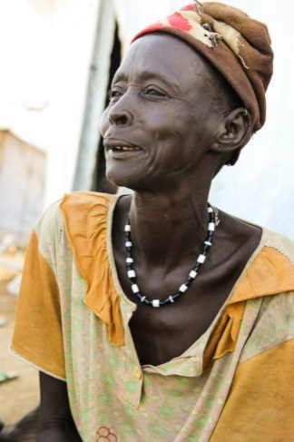

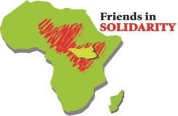

**Friends in Solidarity** [***www.solidarityfriends.org***](http://www.solidarityfriends.org)

***Prayer for South Sudan***

***God of Peace***,

St. Francis prayed, "Lord, make me an instrument of your peace."

And so do we.

Make us instruments of your peace.

Allow instruments of peace to rise up in South Sudan

And flourish all over your world:

instruments of peace who offer stability, safety, and justice;

that bring joy and hope;

that foster hearts of reconciliation, mercy, and love.

***God of Justice,***

The prophet Jeremiah likened your saving justice to towering mountains.

And so do we.

May your justice tower over the people of South Sudan:

Upholding the righteous,

Protecting the widow and orphan,

Staying the hand that seeks violence,

Reconciling brother with brother, sister with sister,

Your children with each other.

***God of Plenty,***

Your Son showed us how in faith, prayer and generosity,

Your bounty could be multiplied.

And so will we.

Bless South Sudan with a bountiful harvest;

Let this conflict not dry its fields

Or close its markets

Or still its people's desire to share what they have.

Banish famine from their land

And turn the hearts of all to those who hunger

That we may all share what you have blessed us with;

That their baskets may be filled,

That their cups may overflow,

That their children may flourish. **Amen** *(Catholic Relief Services)*

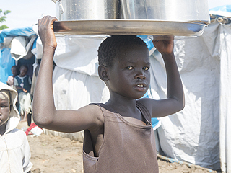

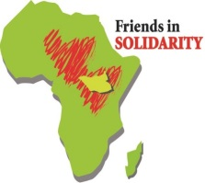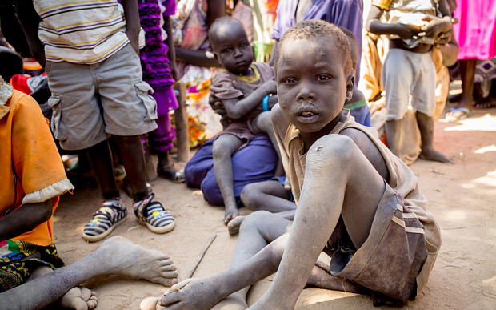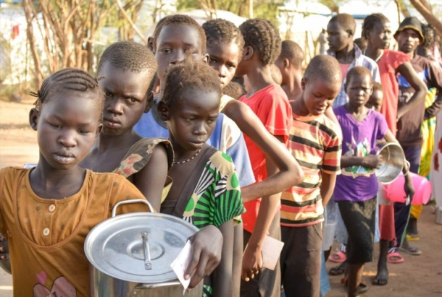

Allow your prayer to lead you to action on behalf of the people of South Sudan

* Learn more about the situation in South Sudan. This is not well covered in the USA.
* Learn more about the work of Friends in Solidarity: [www.solidarityfriends.org](http://www.solidarityfriends.org)
* Like us on Facebook! <https://www.facebook.com/solidarityfriends>
* Support an organization that is working toward capacity building like ***Friends in Solidarity***. <https://www.solidarityfriends.org/donate/>
* Donate to an organization that is providing aid to South Sudan like ***Catholic Relief Services***. <http://www.crs.org/our-work-overseas/where-we-work/south-sudan>

**Friends in Solidarity** *is an initiative of US Catholic religious men and women in support of religious working in South Sudan and beyond. It was incorporated in November 2015 as an outgrowth of interest in the work being done by Solidarity with South Sudan, a project begun by the International Union of Superiors General and the Union of Superiors General in Rome in response to a request of the Sudan Catholic Bishops Conference in 2006.* [www.solidarityfriends.org](http://www.solidarityfriends.org)